- List the minimum perks package.
SELECT MIN(perks) AS minimum_perks
FROM employee_data;
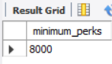
- List the maximum salary given to a “Programmer”.
SELECT MAX(salary) AS max_programmer_salary
FROM employee_data
WHERE title = 'Programmer';
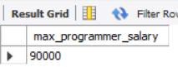
- Display the age of the oldest “Marketing Executive”.
SELECT age
FROM employee_data
WHERE title = 'Marketing Executive'
ORDER BY age DESC
LIMIT 1;
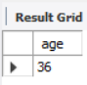
- (Tricky!) Find the first and last names of the oldest employee.
SELECT f_name, l_name, age
FROM employee_data
ORDER BY age DESC
LIMIT 1;
